Task on CloudTrail & CloudWatch
1. Enable CloudTrail monitoring and store the events in S3 and CloudWatch log events.
Step 1: Create a Trail
- Go to the CloudTrail console (you already have the us-east-1 tab open).
- Click Create trail.
- Enter a name OrgTrail.
- Choose Apply trail to all regions (recommended for complete coverage).
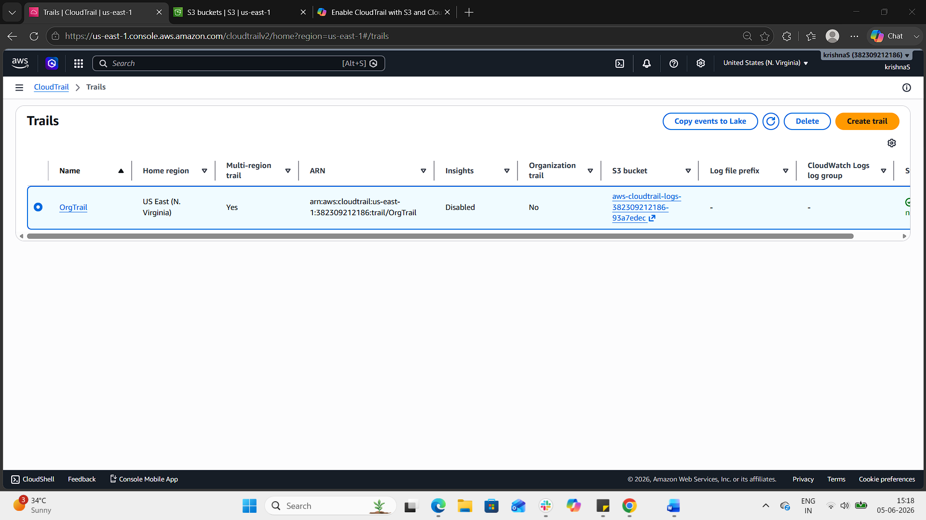
Step 2: Configure S3 Storage
- In the Storage location section, select Create new S3 bucket or choose an existing one.
  - Example bucket name: aws-CloudTrail-OrgTrail.
- CloudTrail will automatically create a folder structure inside the bucket for logs.
- Ensure the bucket policy allows CloudTrail to write logs.
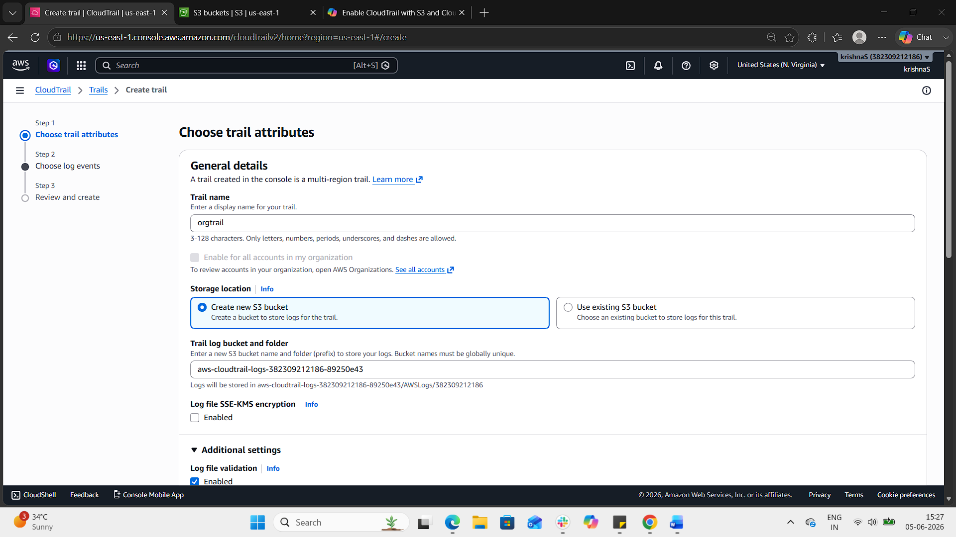
Step 3: Enable CloudWatch Logs
- In the CloudWatch Logs section, choose Enabled.
- Select an existing log group or create a new one (e.g., /aws/cloudtrail/OrgTrail).
- CloudTrail will create a role with permissions to publish logs to CloudWatch.
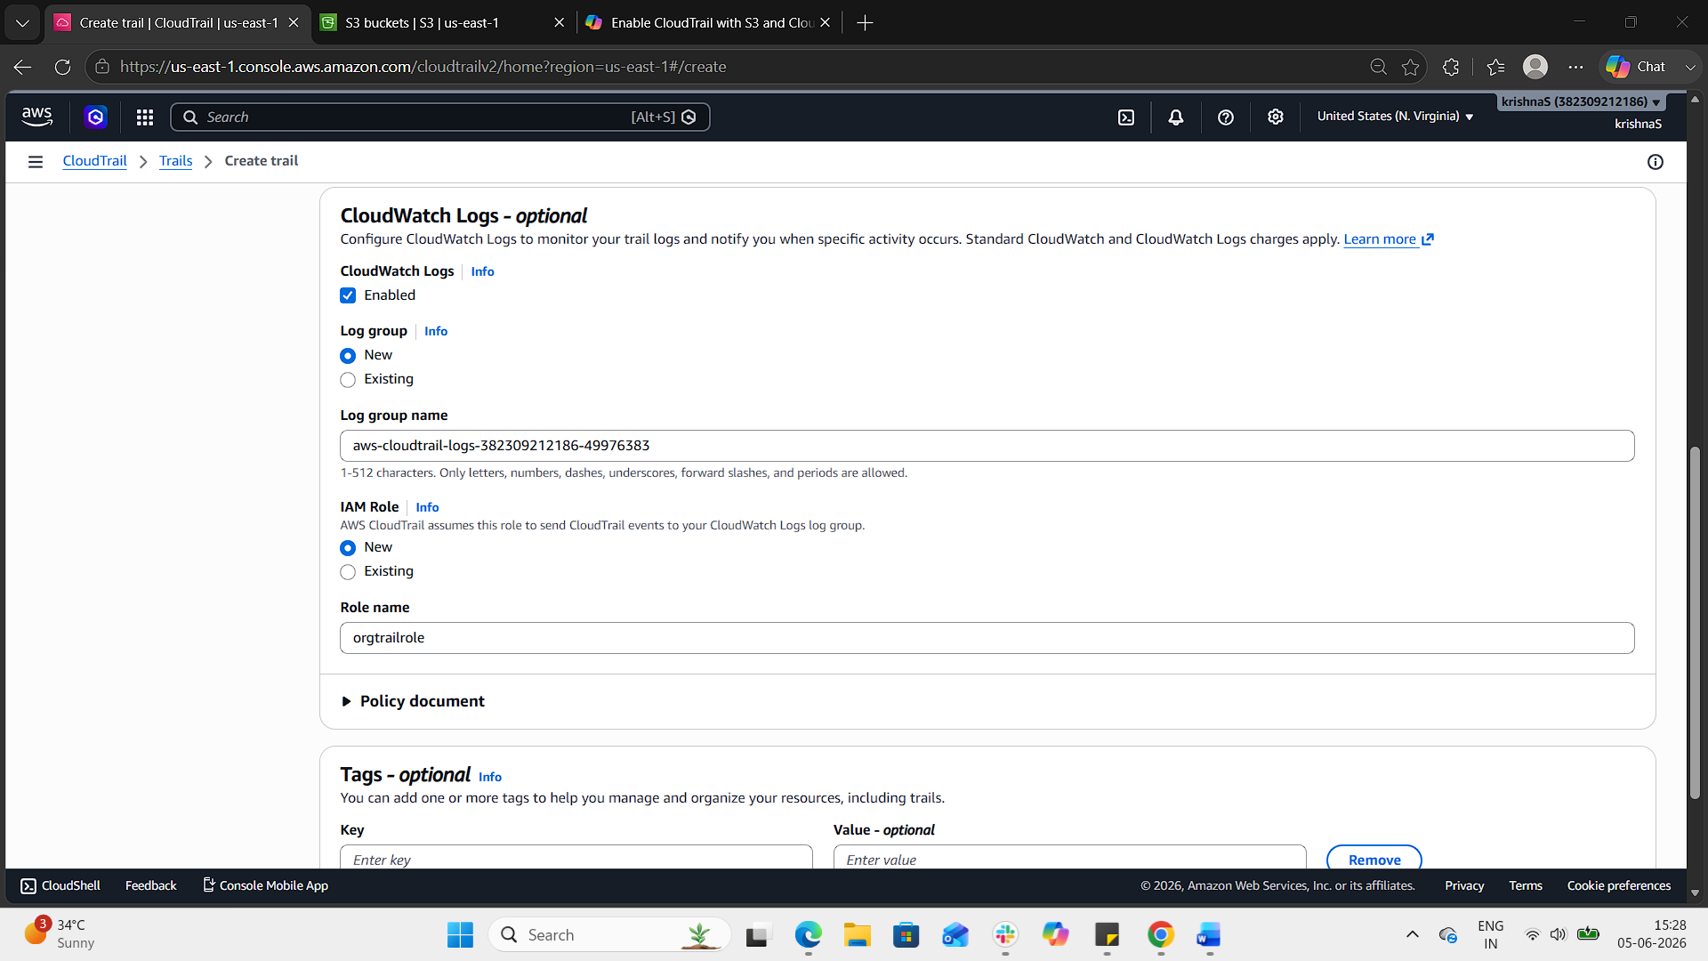
Step 4: Choose log events
- select management events under events section.
- select read and write options of api activity under management events.
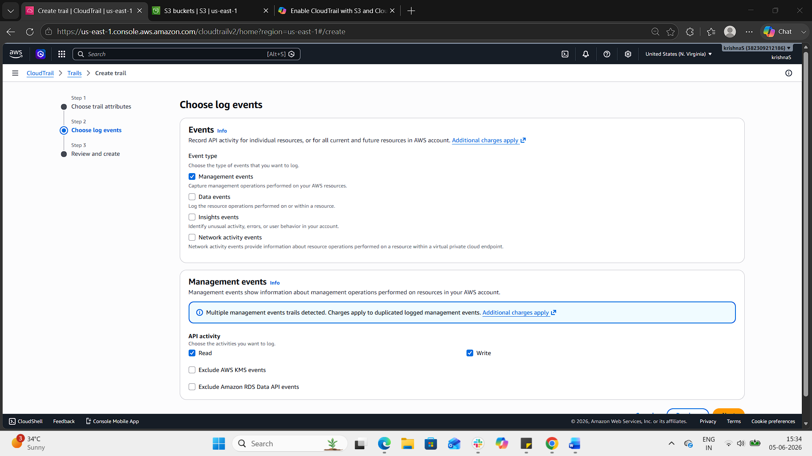
Step 4: Review and Create
- Review your settings.
- Click Create trail.
- CloudTrail will now deliver logs to both S3 and CloudWatch Logs.
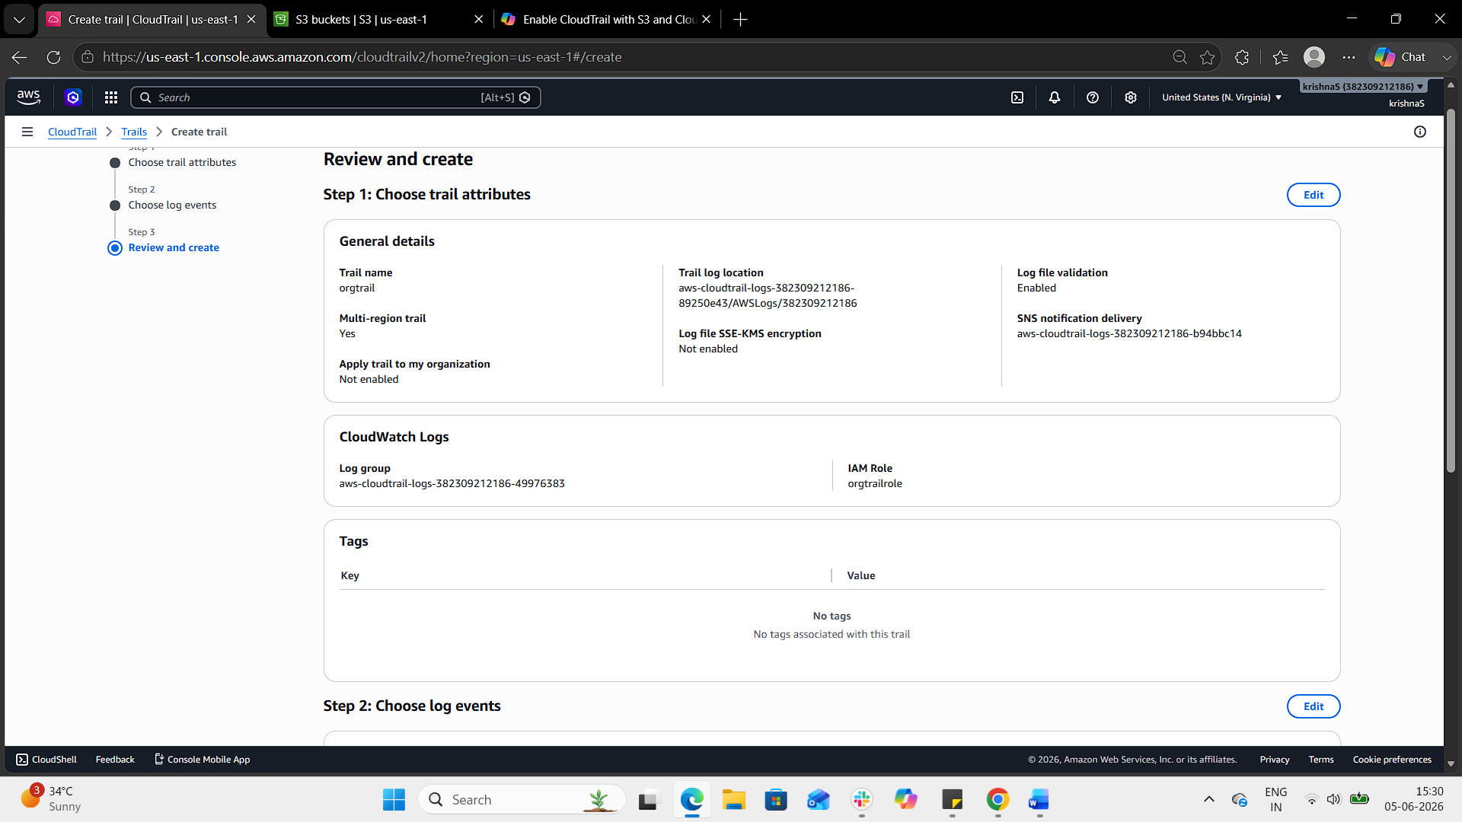
Verification
- S3: Navigate to your bucket → check for log files under AWSLogs/<account-id>/CloudTrail/.
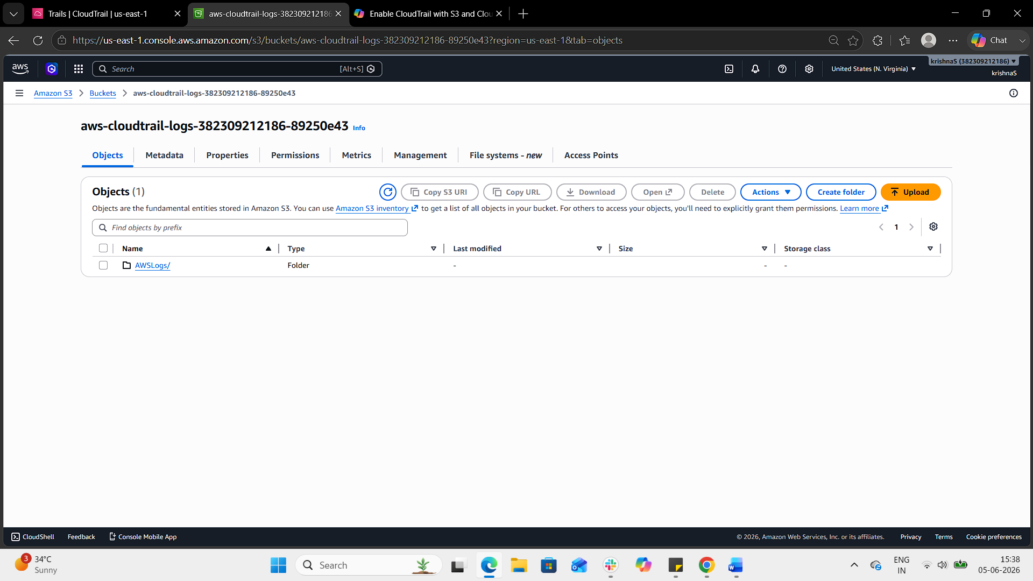
- CloudWatch Logs: Go to CloudWatch → Log groups → /aws/cloudtrail/OrgTrail → verify events are streaming in.
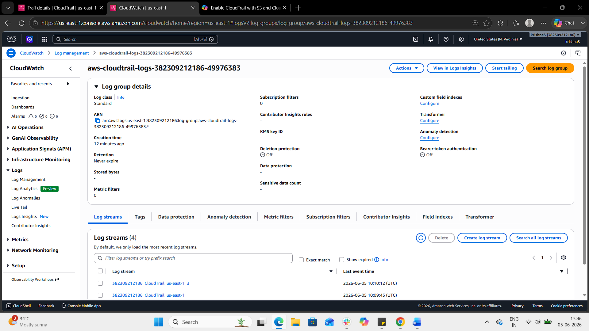
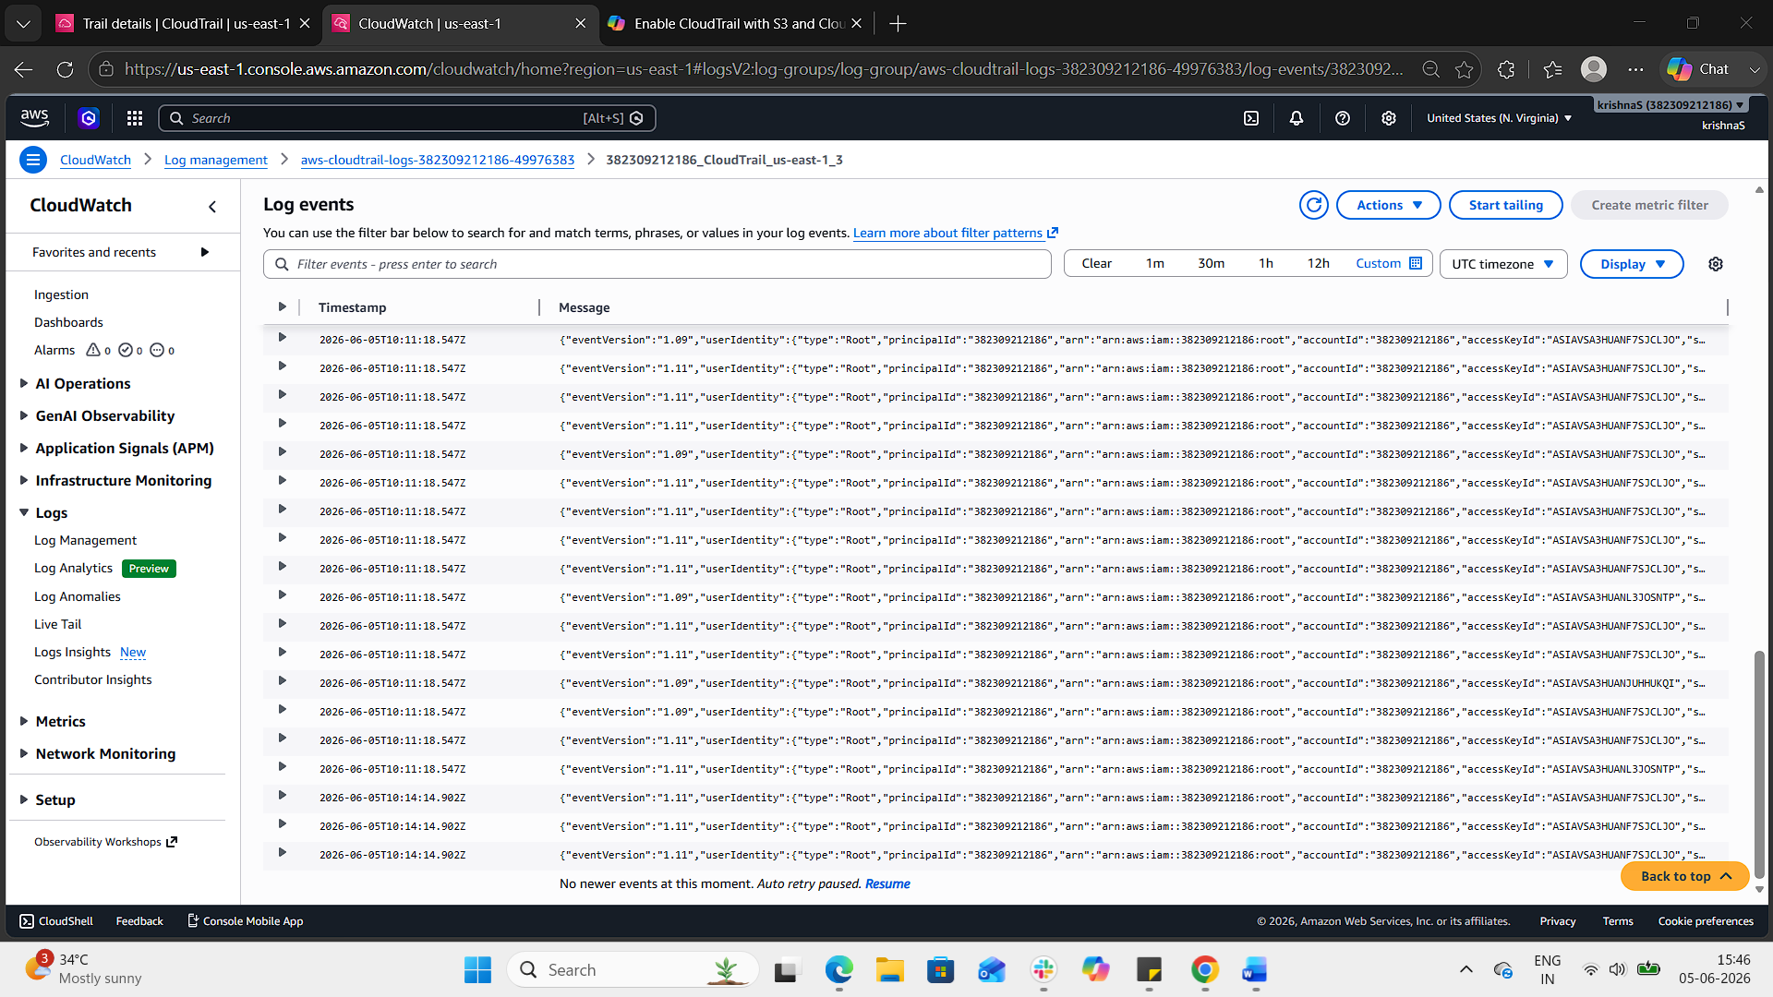
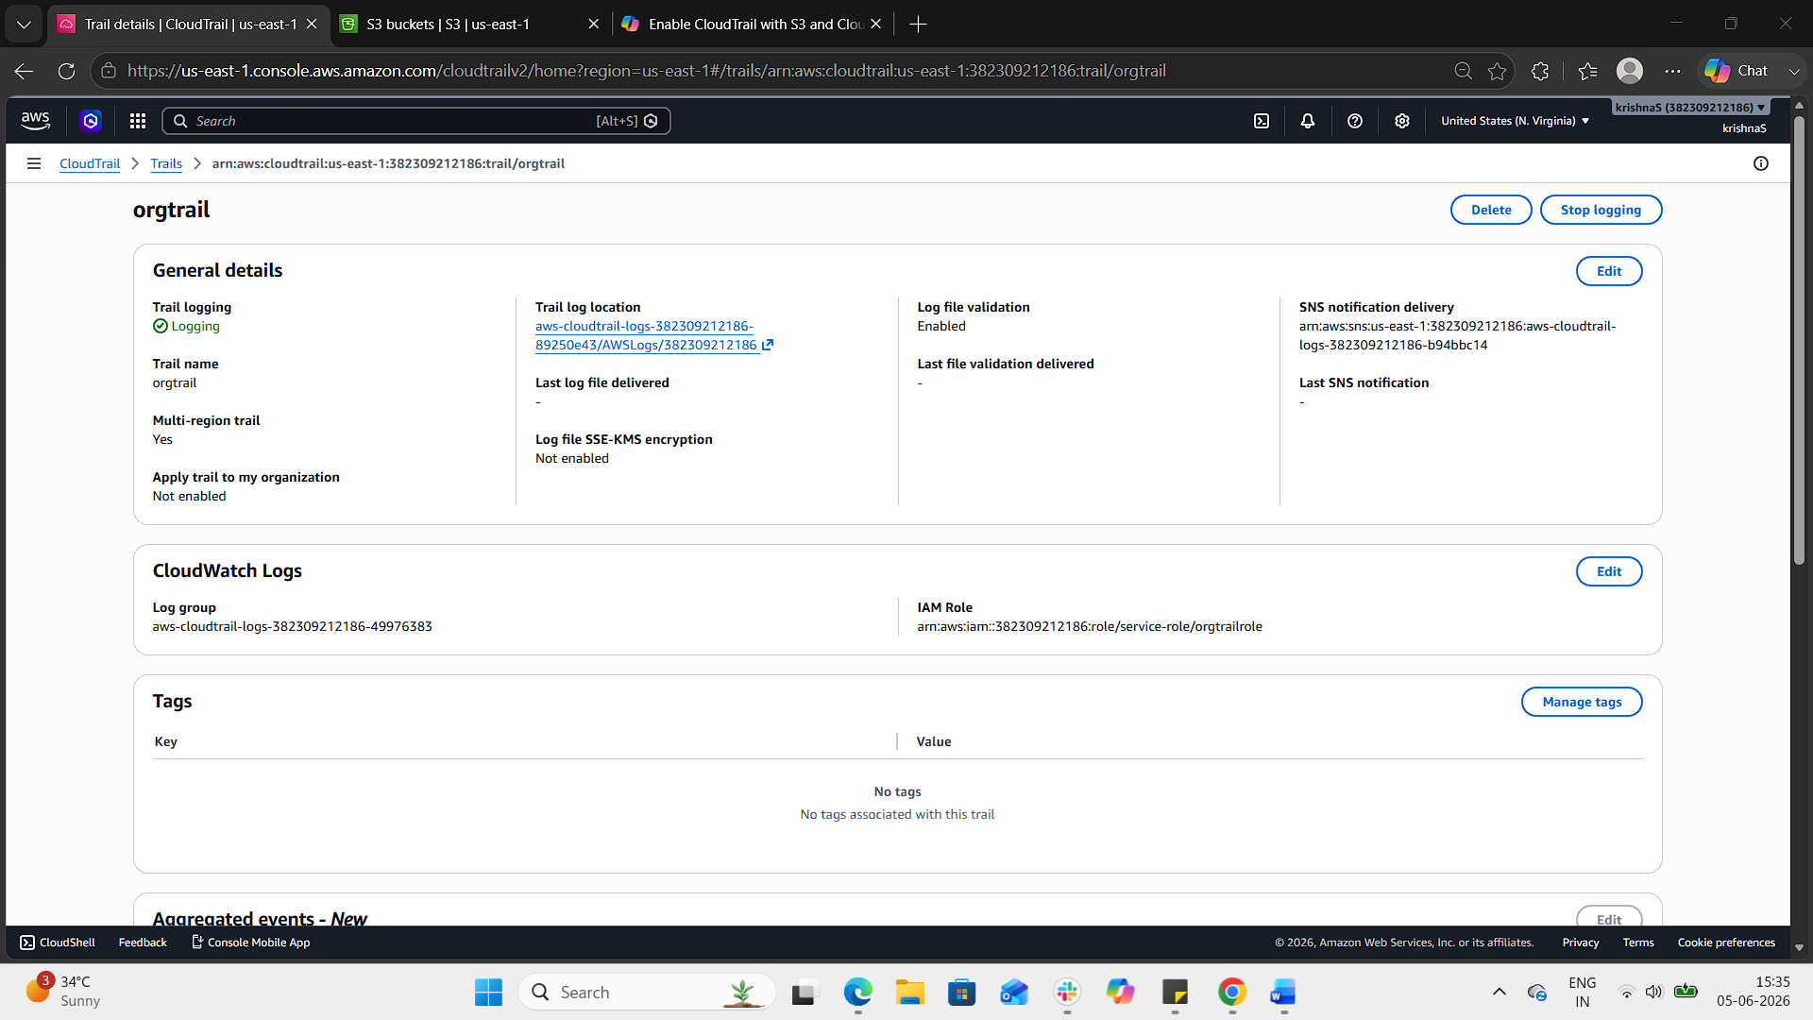
2. Enable SNS for CloudTrail to send alerts via email.
Step 1: Create an SNS Topic
- Go to the SNS Console.
- Click Create topic → choose Standard.
- Enter a name (e.g., CloudTrail-Alerts).
- Click Create topic.
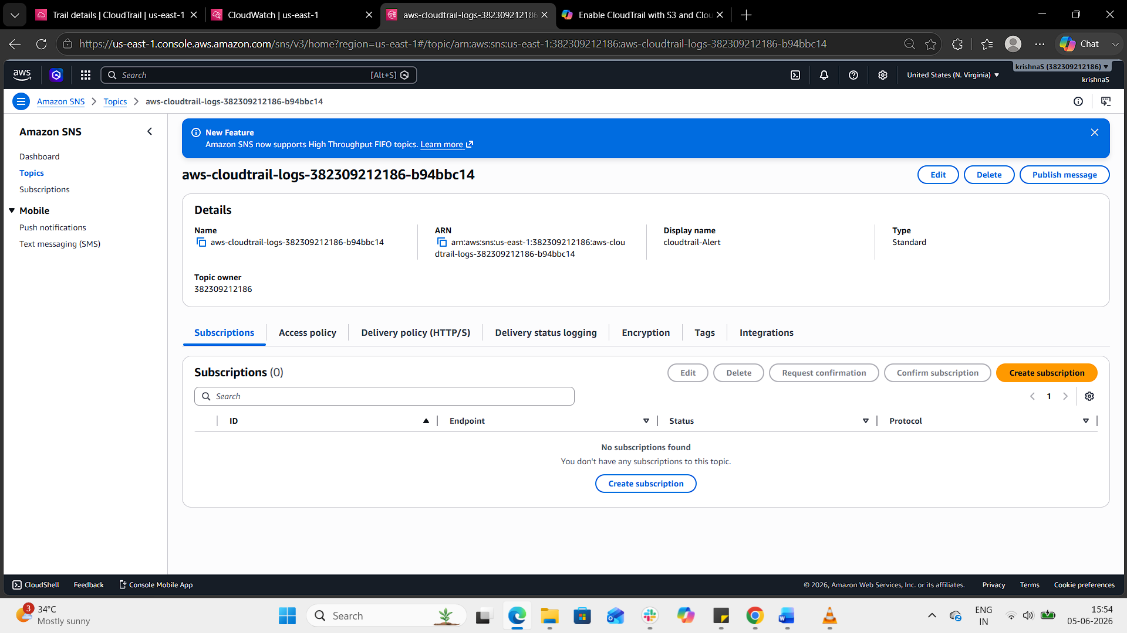
Step 2: Subscribe Your Email
- Open the topic you just created.
- Click Create subscription.
- Protocol: Email.
- Endpoint: Enter your email address.
- You’ll receive a confirmation email → click the link to confirm.
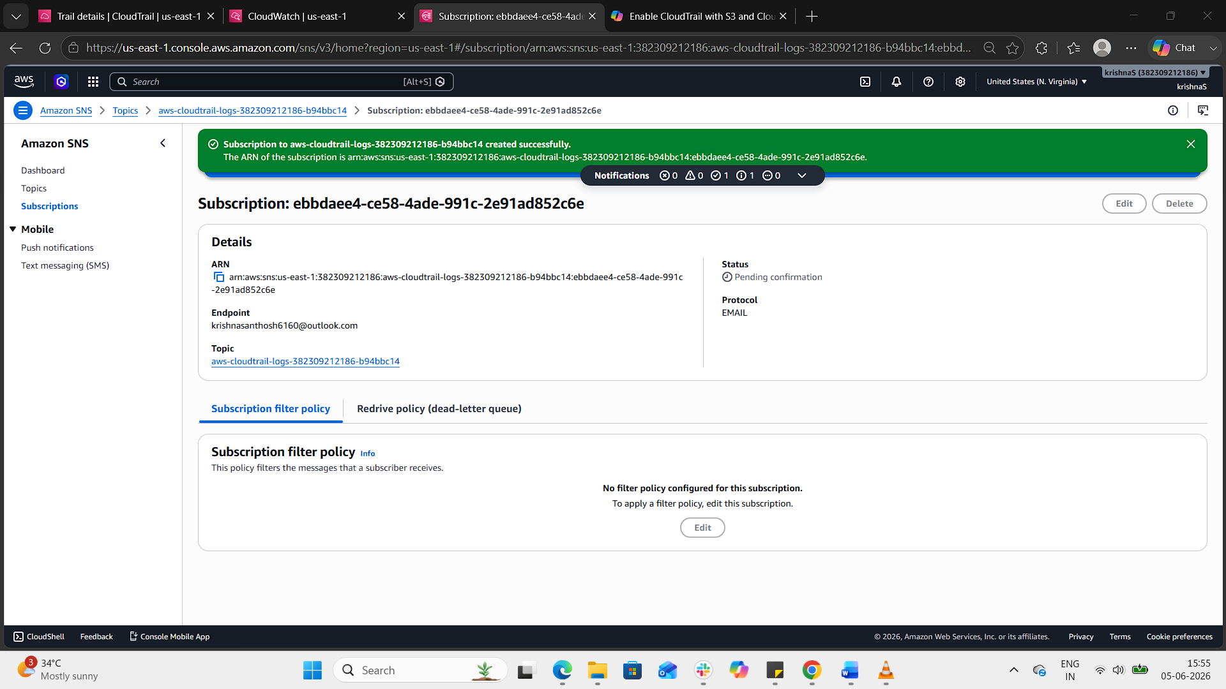
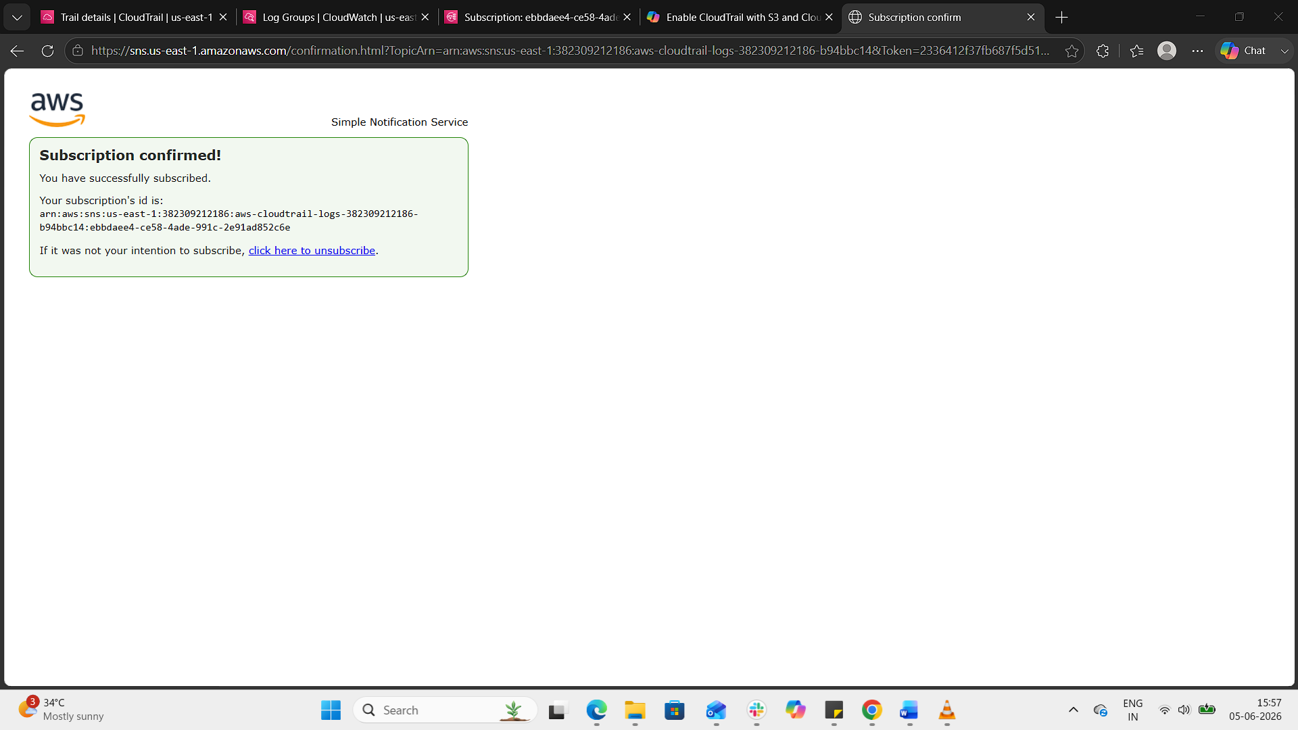
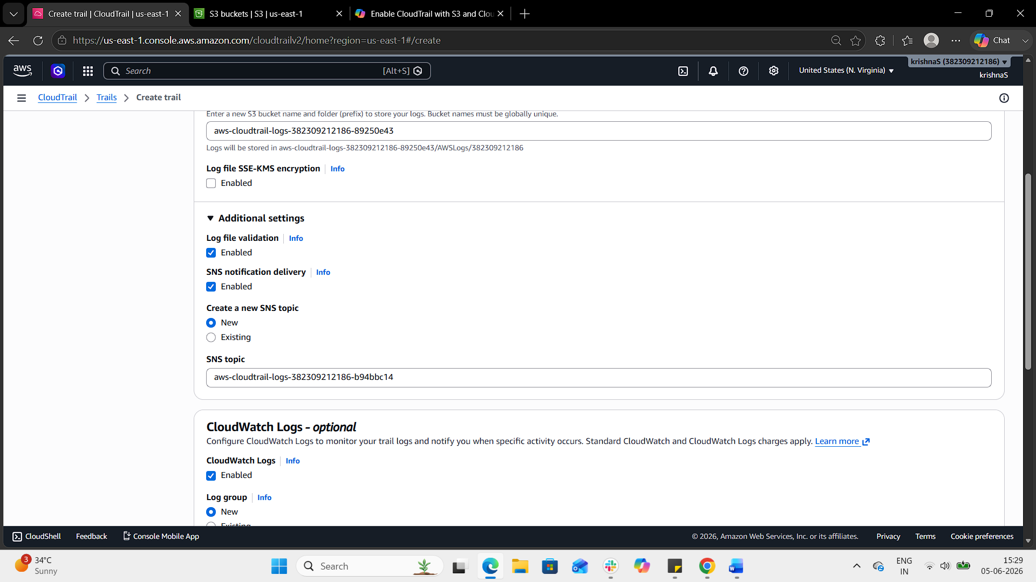
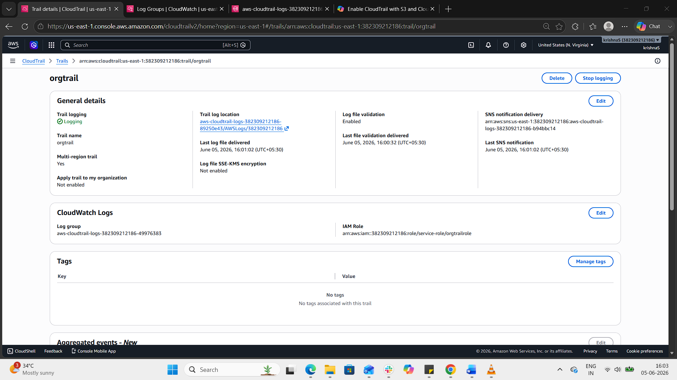
Result
- CloudTrail logs → CloudWatch Logs.
- SNS sends an email alert to you.
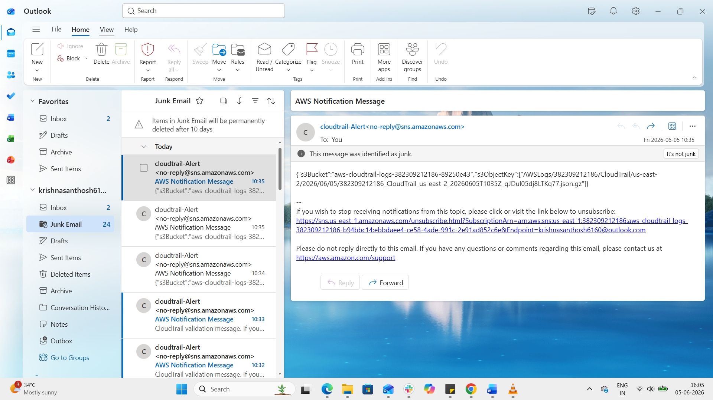
3. Configure CloudWatch monitoring and record the CPU utilization and other metrics of EC2.
Step 1: Enable Detailed Monitoring
- Go to the EC2 Console.
- Select your instance → Monitoring tab.
- By default, EC2 provides basic monitoring (5-minute intervals).
- Click Enable detailed monitoring to get 1-minute granularity.
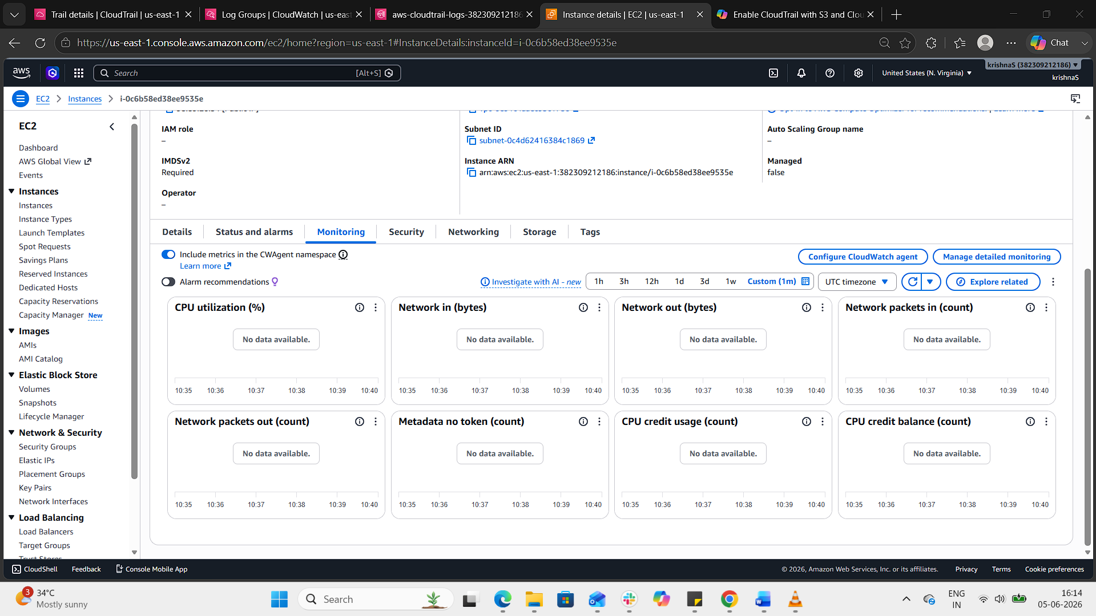
Step 2: View Metrics in CloudWatch
- Open the CloudWatch Console (you already have the us-east-1 tab open).
- Navigate to Metrics → EC2.
- Select your instance ID.
- You’ll see metrics like:
  - CPUUtilization (% of CPU used)
  - NetworkIn / NetworkOut (bytes transferred)
  - DiskReadOps / DiskWriteOps
  - StatusCheckFailed (health checks)
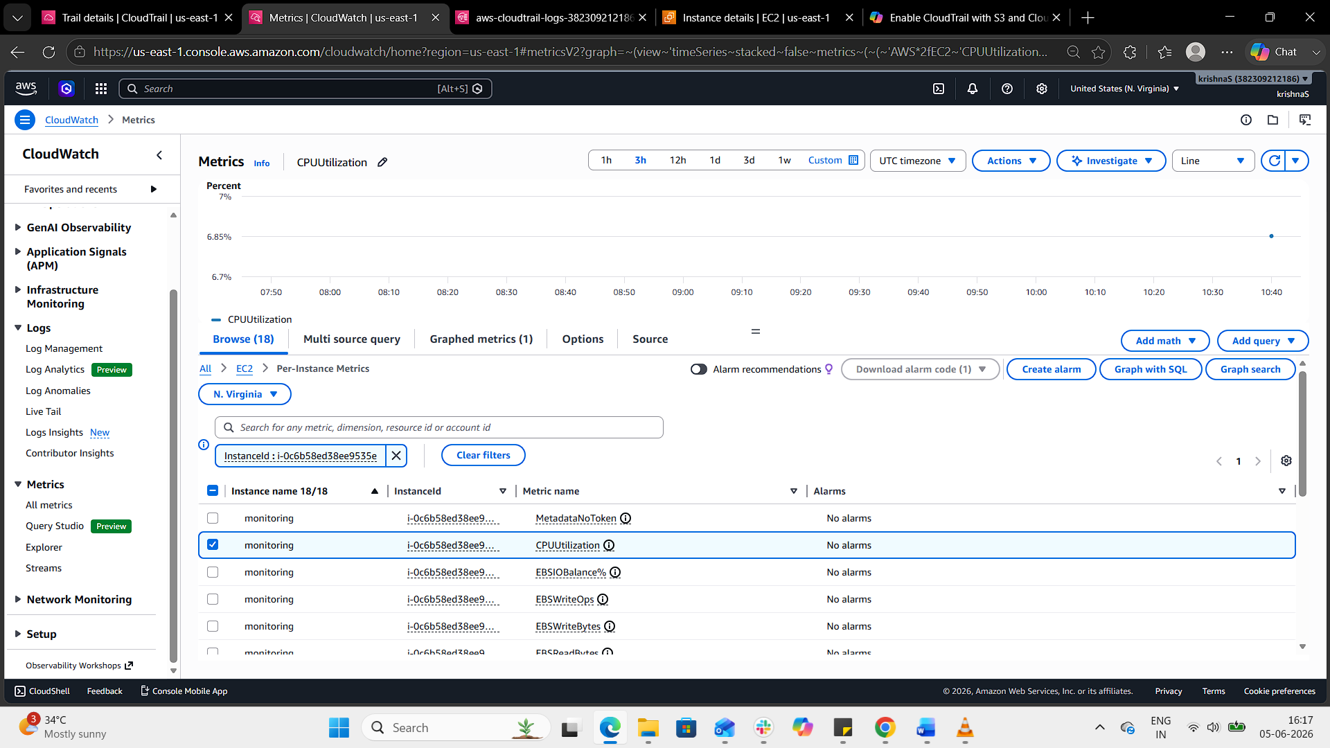
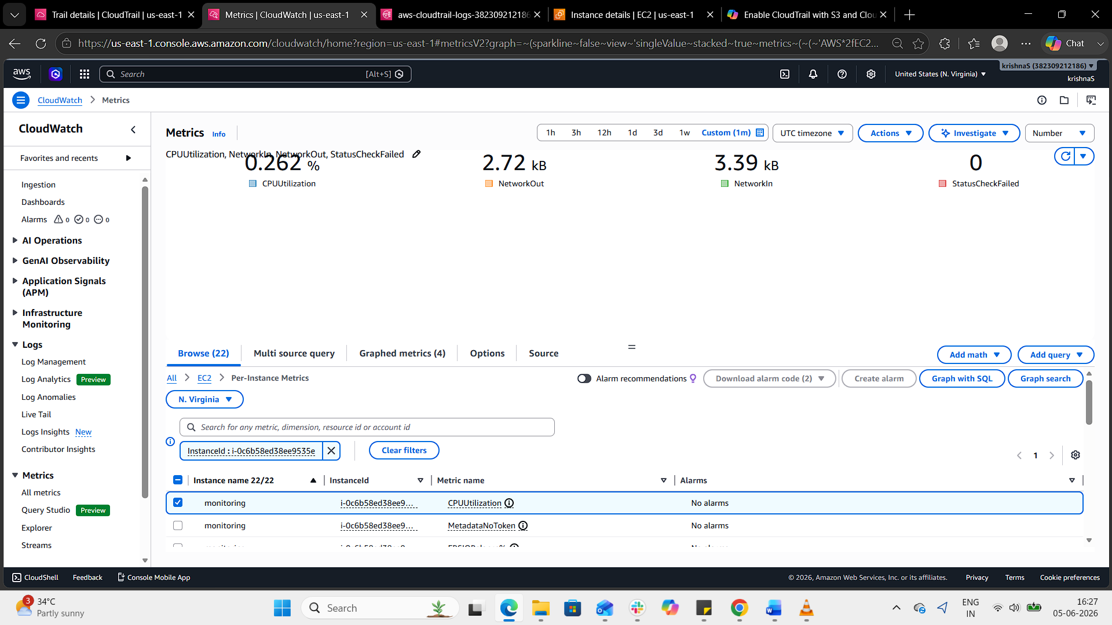
Result
- CPU utilization and other EC2 metrics are recorded in CloudWatch.
- Custom metrics give deeper visibility into memory and disk usage.

4. Create one alarm to send an alert to email if the CPU utilization is more than 70 percent.
Step 1: Ensure SNS Topic Exists
- Confirm the subscription via the email you receive.
Step 2: Create the Alarm in CloudWatch
- Go to the CloudWatch Console → Alarms → Create alarm.
- Choose EC2 → Per-Instance Metrics → CPUUtilization.
- Select your instance ID.
- Define the threshold:
  - Condition: CPUUtilization > 70
  - Period: 5 minutes (or 1 minute if detailed monitoring is enabled).
  - Evaluation periods: 2 (so it triggers only if sustained).
- Under Actions, choose Send notification to SNS topic → select EC2-CPU-Alerts.
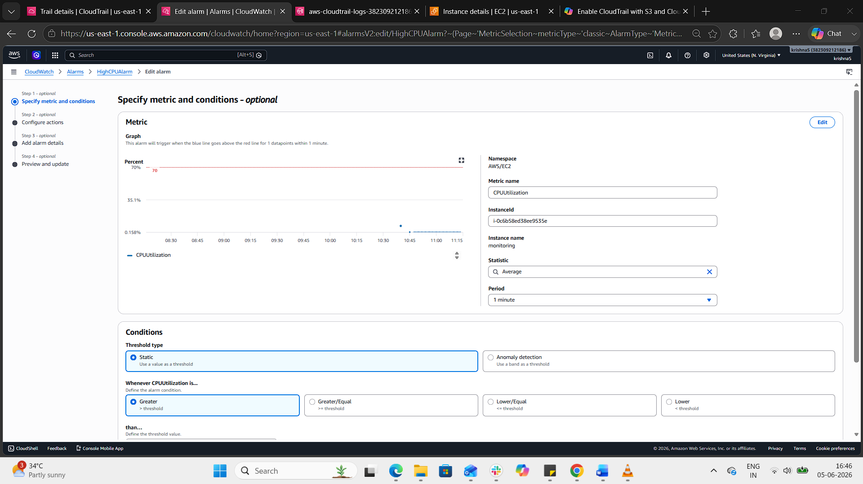
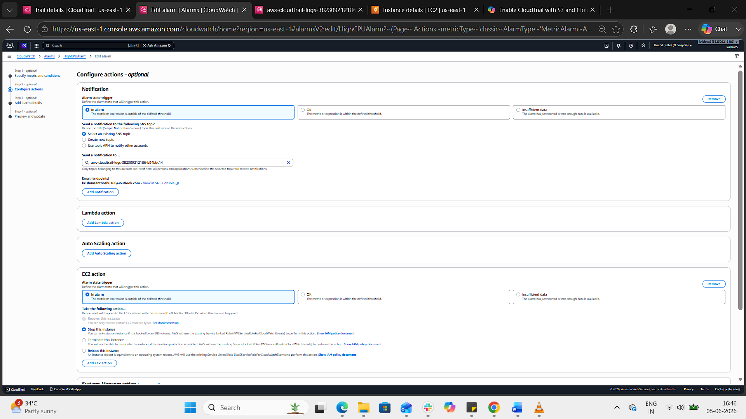
Step 3: Review and Create
- Name the alarm (e.g., HighCPUAlarm).
- Review settings.
- Click Create alarm.
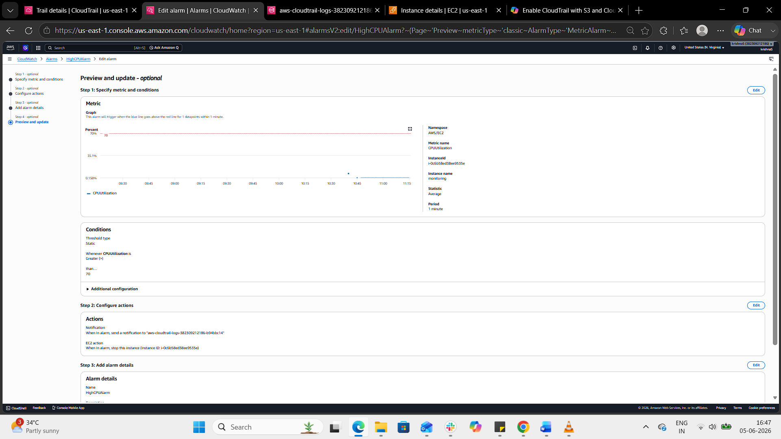
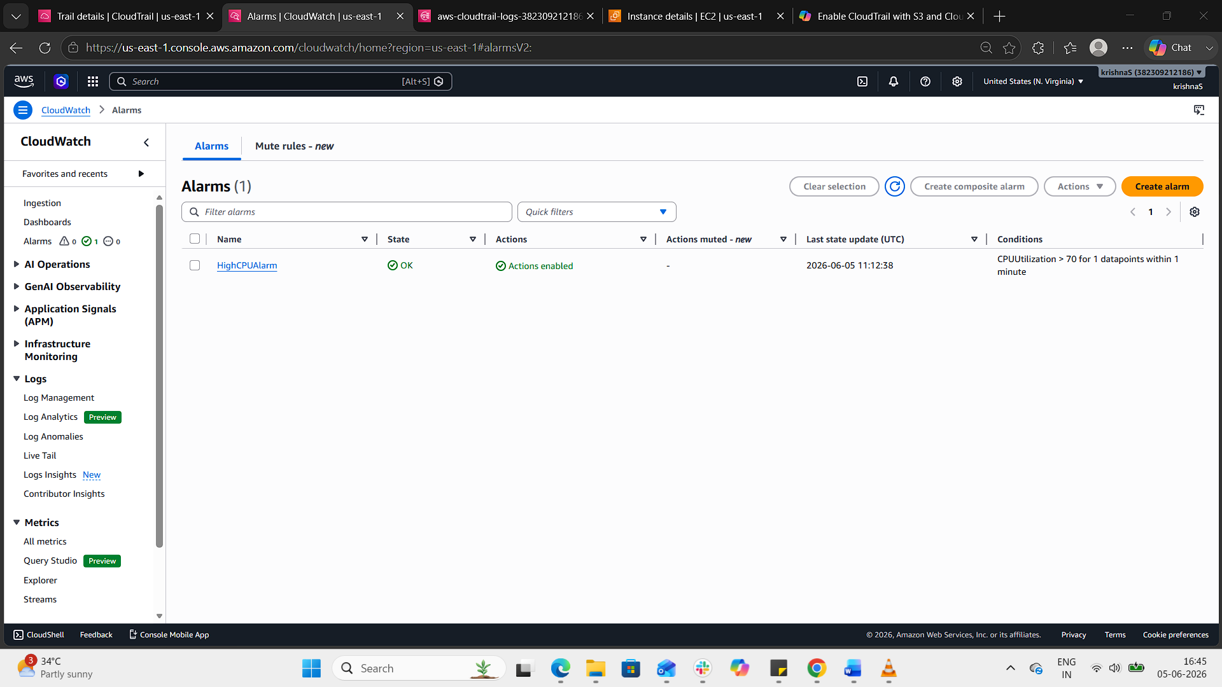
Result
- CloudWatch continuously monitors CPU utilization.
- If it goes above 70%, the alarm triggers.
- SNS sends an email alert to your subscribed address.
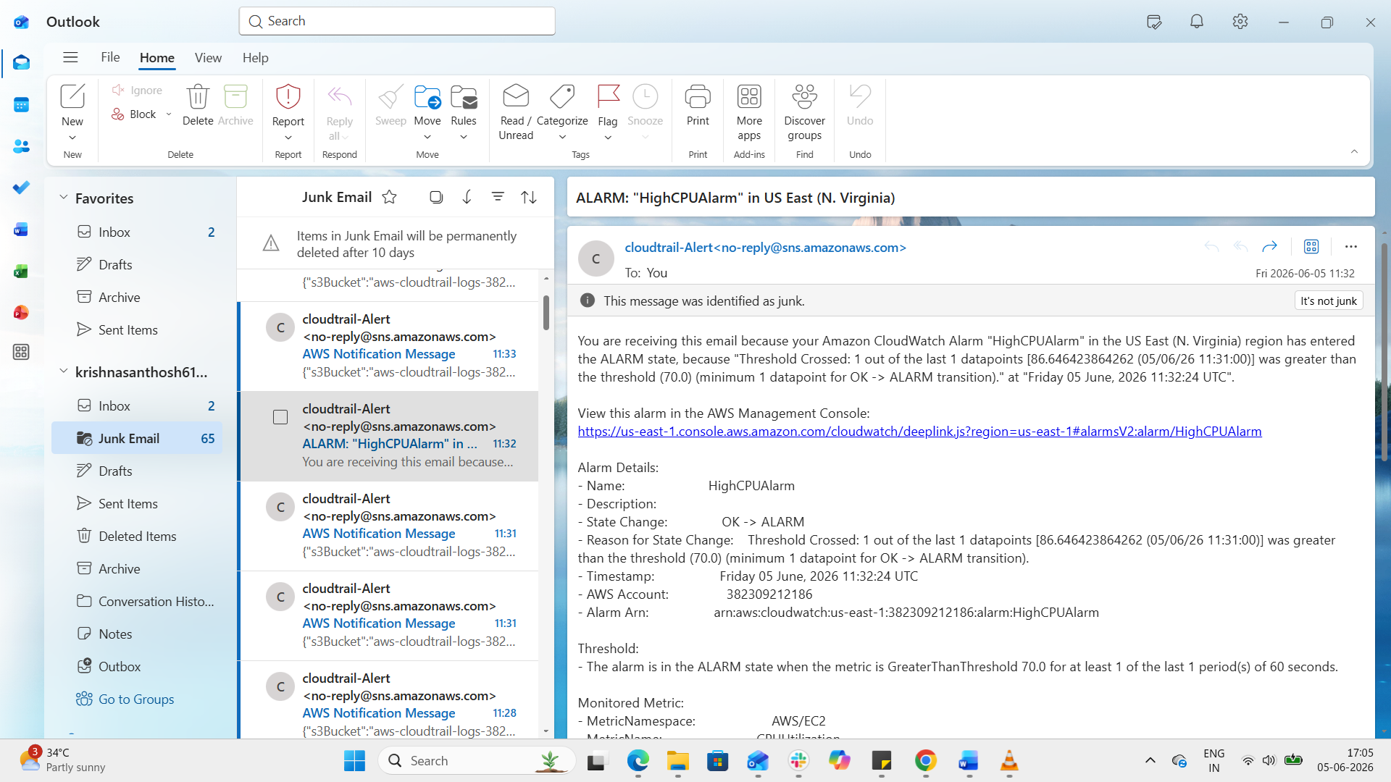
5. Create a Dashboard and monitor the Tomcat service whether it is running or not and send the alert.
Step 1: Verify Tomcat Service Status
Connected to the EC2 instance:
Verified Tomcat service status:
sudo systemctl status tomcat
Output:
Active: active (running)

Step 2: Install CloudWatch Agent
Installed CloudWatch Agent:
sudo yum install amazon-cloudwatch-agent -y
Verified installation:
amazon-cloudwatch-agent-ctl -a status
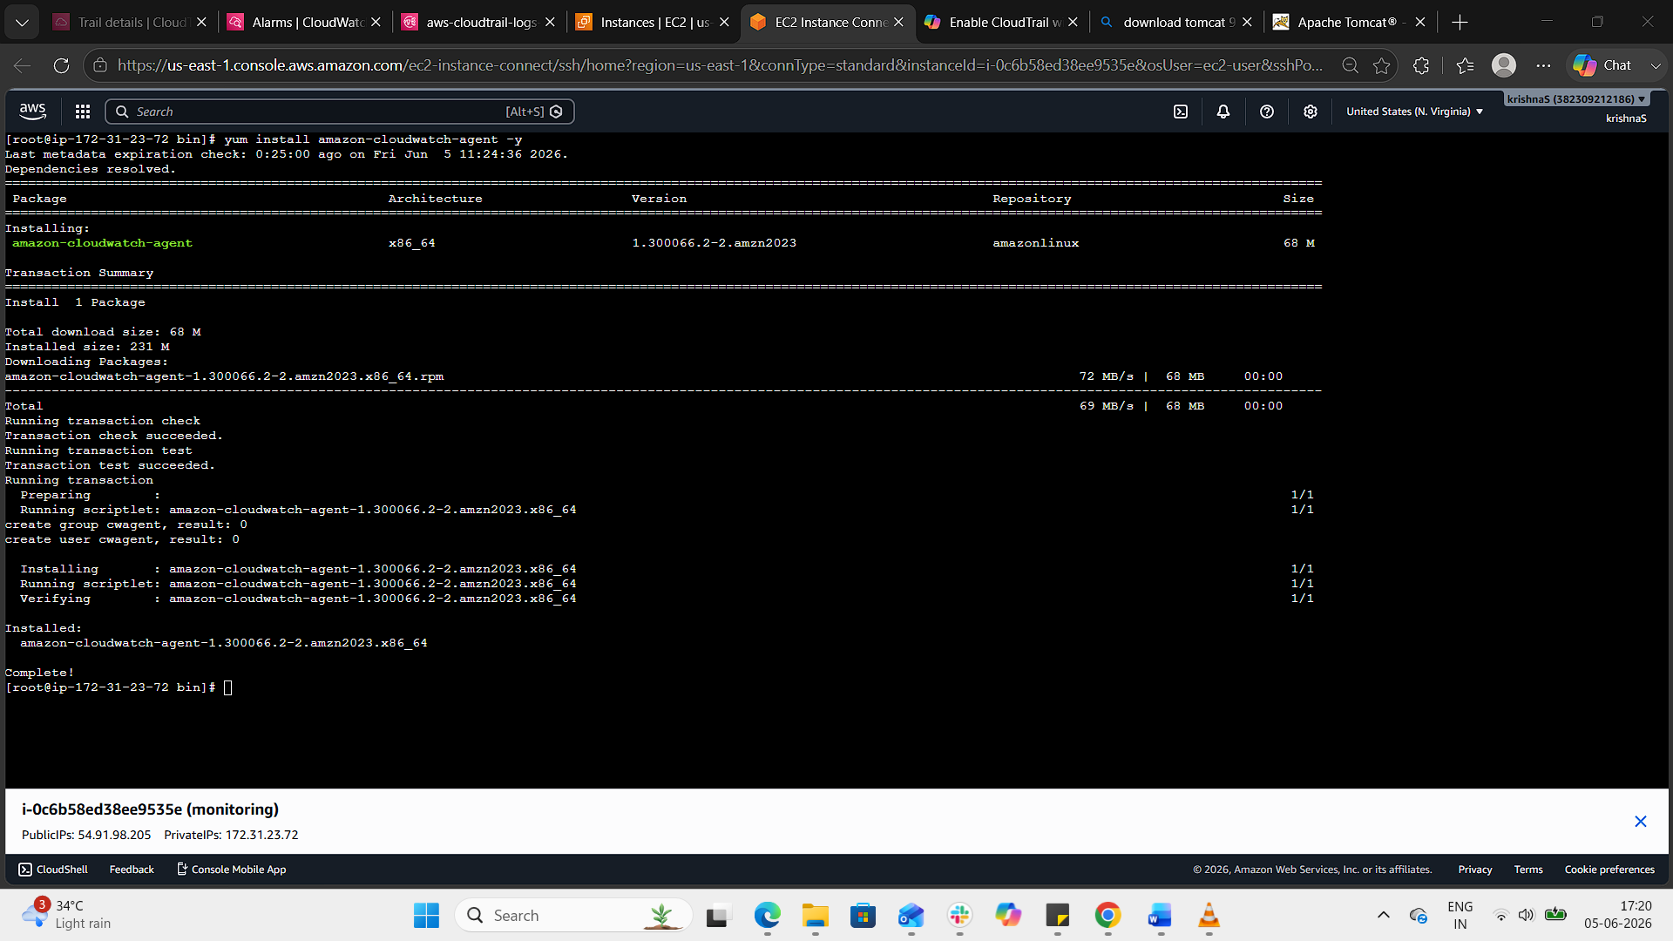
Step 3: Create Tomcat Monitoring Script
Created a custom script:
sudo vi /opt/tomcat-status.sh
Script content:
#!/bin/bash

if systemctl is-active --quiet tomcat
then
aws cloudwatch put-metric-data \
--metric-name TomcatStatus \
--namespace Custom/Tomcat \
--value 1
else
aws cloudwatch put-metric-data \
--metric-name TomcatStatus \
--namespace Custom/Tomcat \
--value 0
fi
Provided execute permissions:
chmod +x /opt/tomcat-status.sh
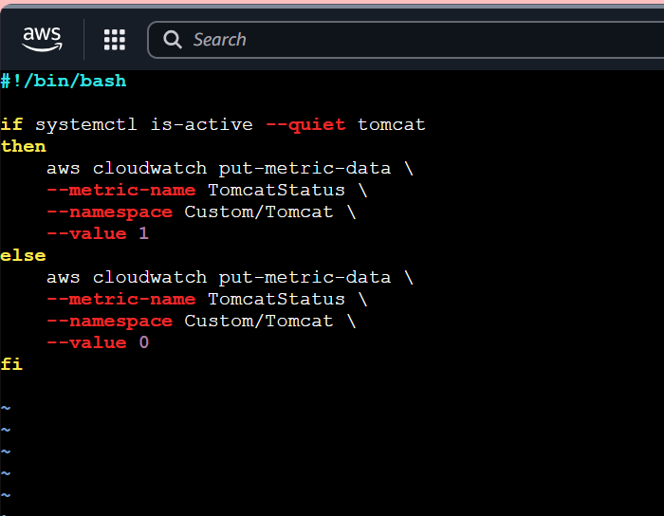
Step 4: Schedule Metric Collection
Configured cron job:
crontab -e
Added:
*/1 * * * * /opt/tomcat-status.sh
Purpose:
- Send Tomcat status metric every minute.
- Value = 1 → Tomcat Running
- Value = 0 → Tomcat Stopped
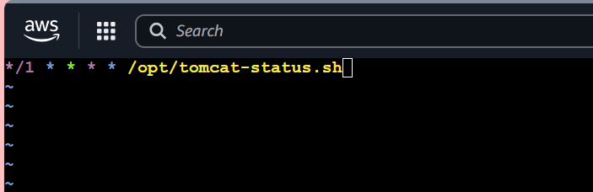
Step 5: Verify Custom Metric
Navigated to:
CloudWatch → Metrics → Custom Namespaces
Selected:
Custom/Tomcat
Verified metric:
TomcatStatus
Expected values:
Value | Meaning
1 | Running
0 | Stopped
Evidence: Screenshot of Custom Metric.
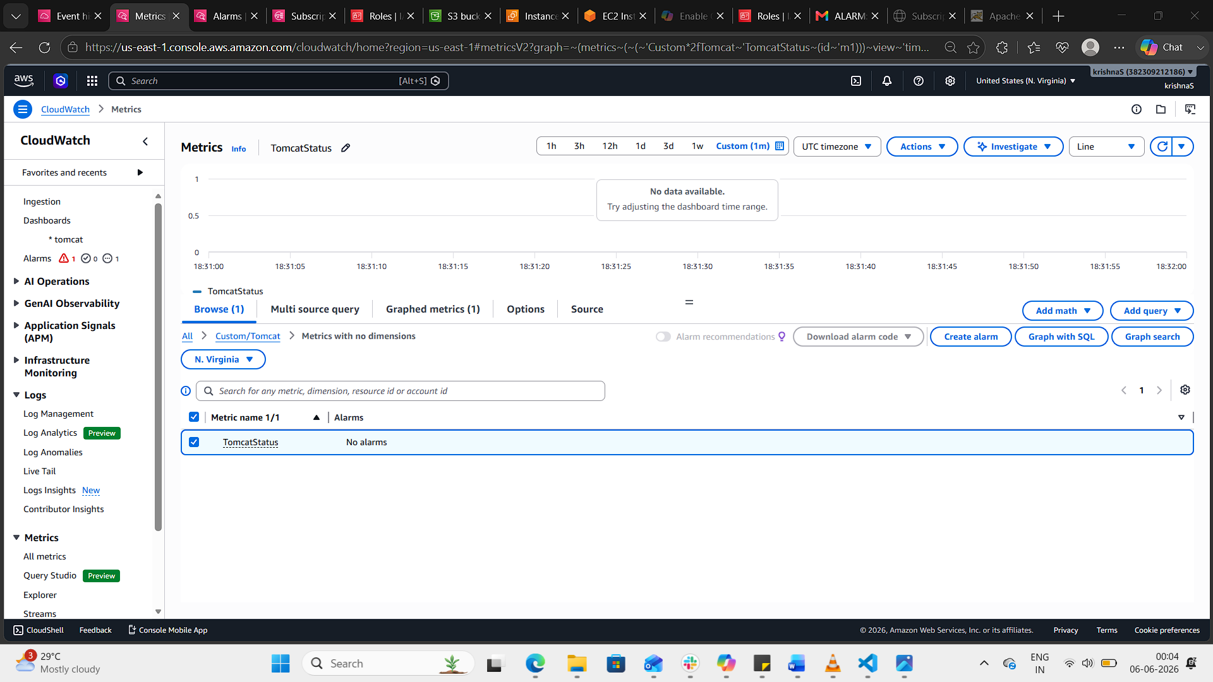
Step 6: Create CloudWatch Dashboard
- Opened CloudWatch Dashboard.
- Clicked Create Dashboard.
- Entered Dashboard Name:
Tomcat-Monitoring-Dashboard
- Added widget:
Metric | Namespace
TomcatStatus | Custom/Tomcat
- Saved Dashboard.
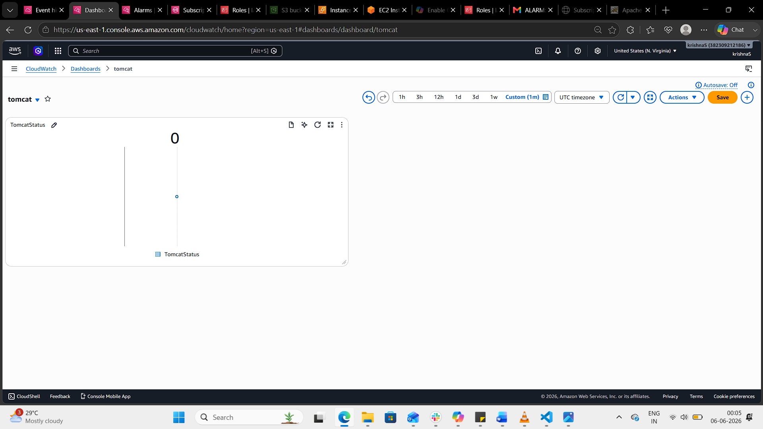
Step 7: Create CloudWatch Alarm
Navigated to:
CloudWatch → Alarms → Create Alarm
Selected metric:
Custom/Tomcat → TomcatStatus
Configured:
Parameter | Value
Threshold Type | Static
Condition | Less Than
Threshold Value | 1
Evaluation Period | 1 Minute
Meaning:
- Alarm triggers if Tomcat status becomes 0.
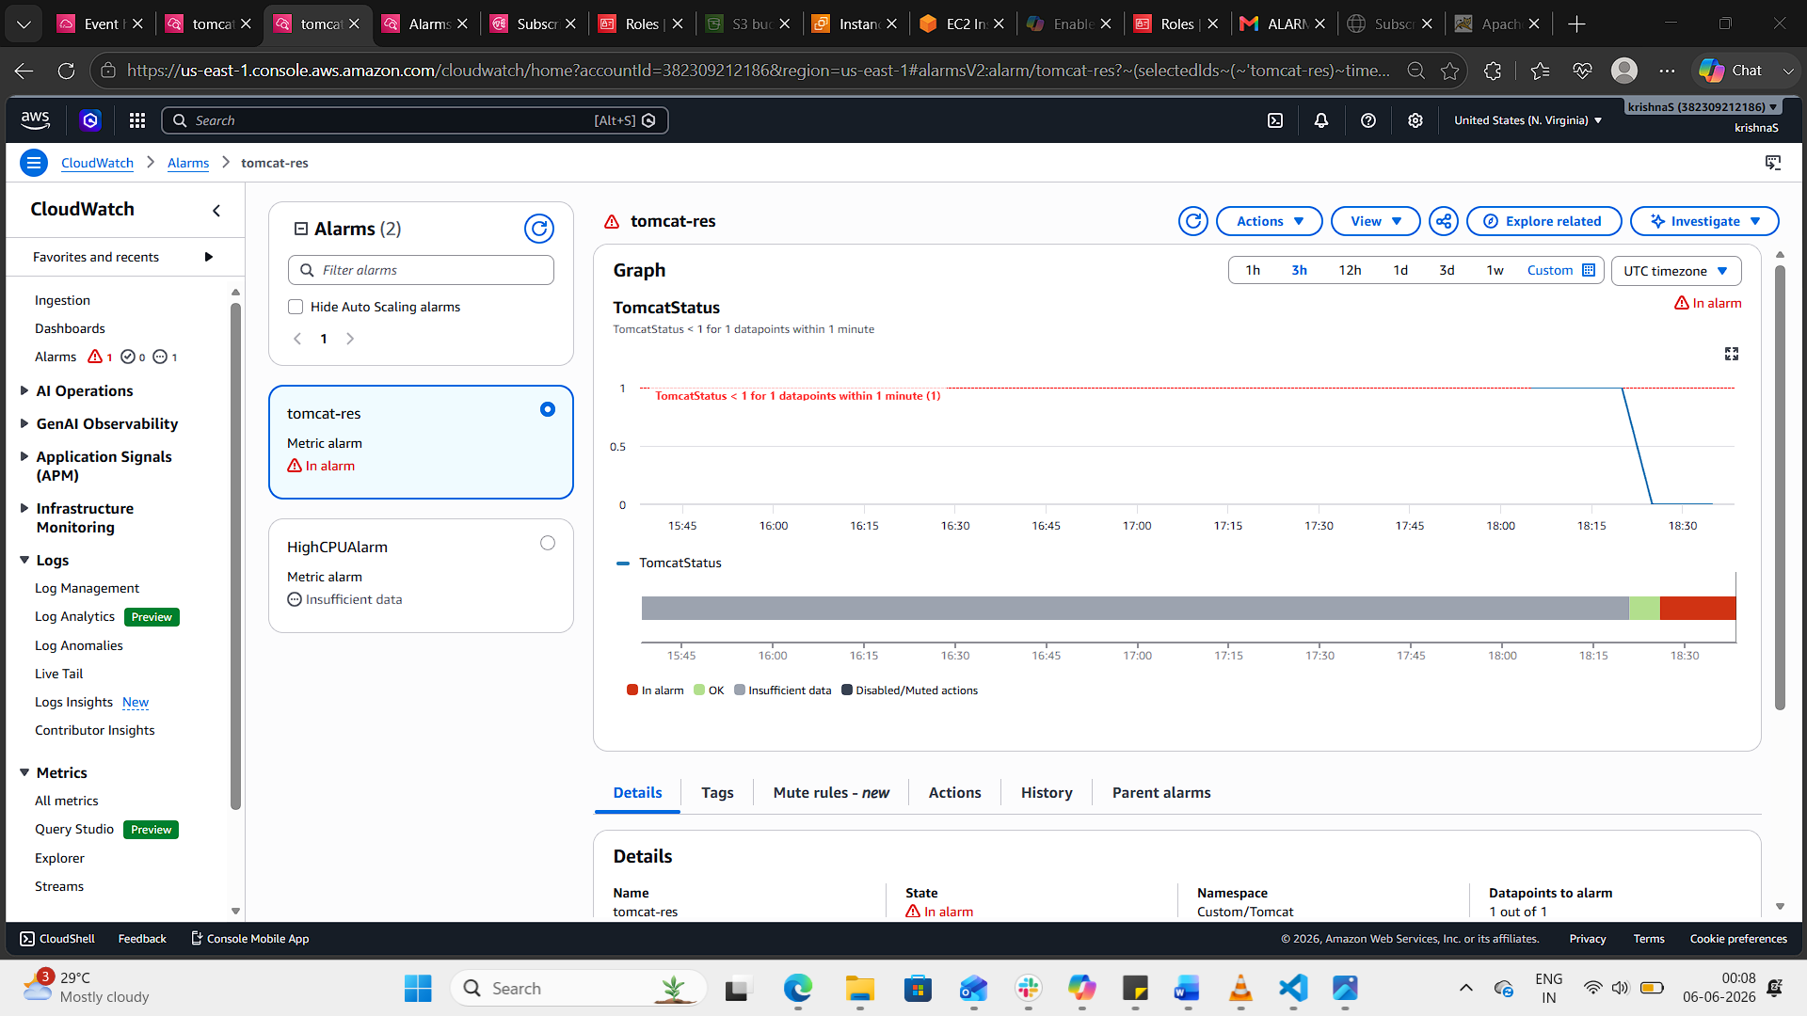
Step 8: Configure SNS Notification
Selected:
Send notification to existing SNS Topic
SNS Topic:
CloudTrail-Alerts
Alarm Name:
Tomcat-Service-Down
Created Alarm.
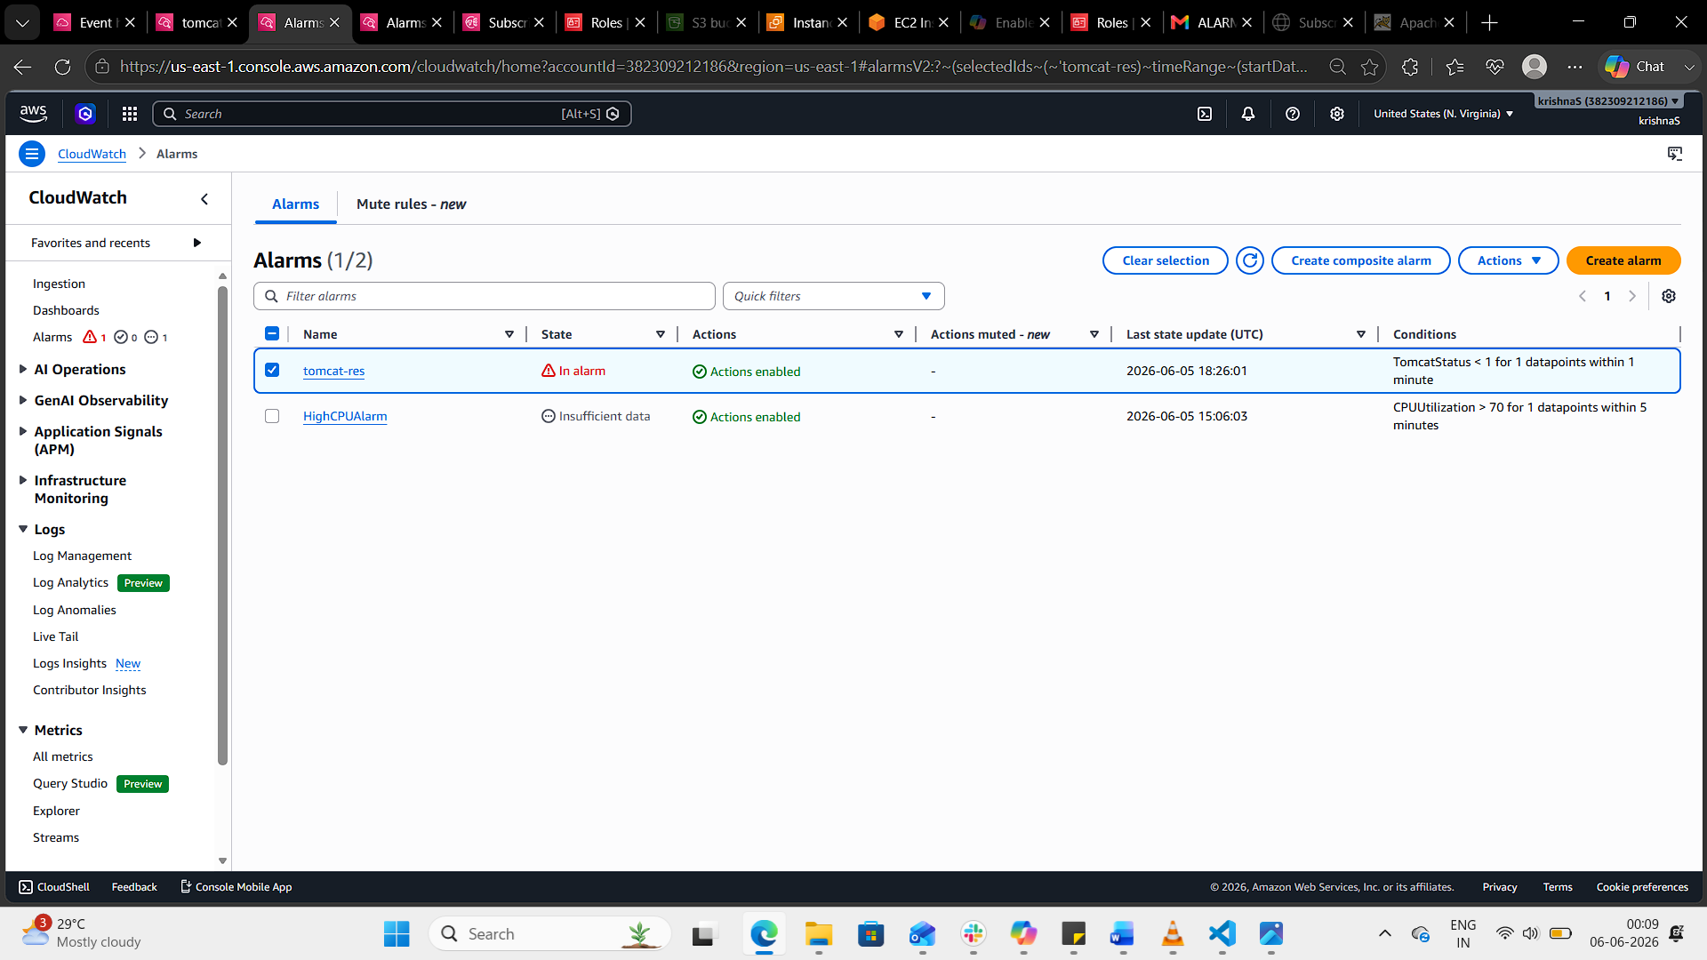
Step 9: Test the Alarm
Stopped Tomcat:
sudo systemctl stop tomcat
Verified:
sudo systemctl status tomcat
Output:
inactive (dead)
Observed:
- Custom metric changed from 1 to 0.
- CloudWatch Alarm entered ALARM state.
- Email notification received.
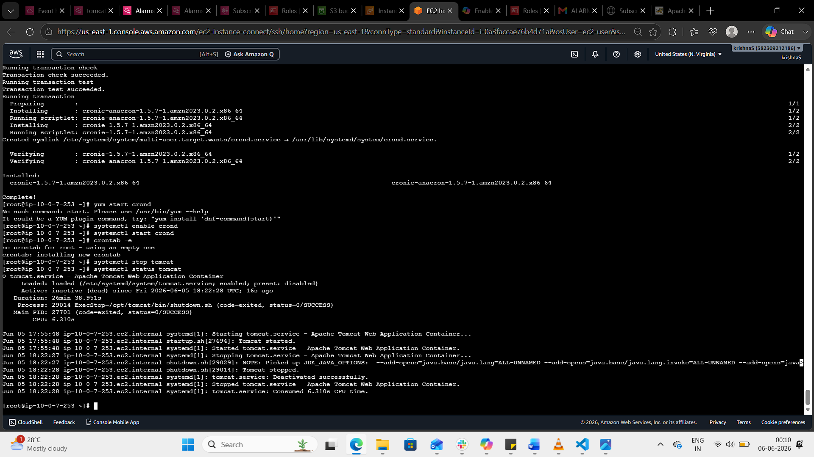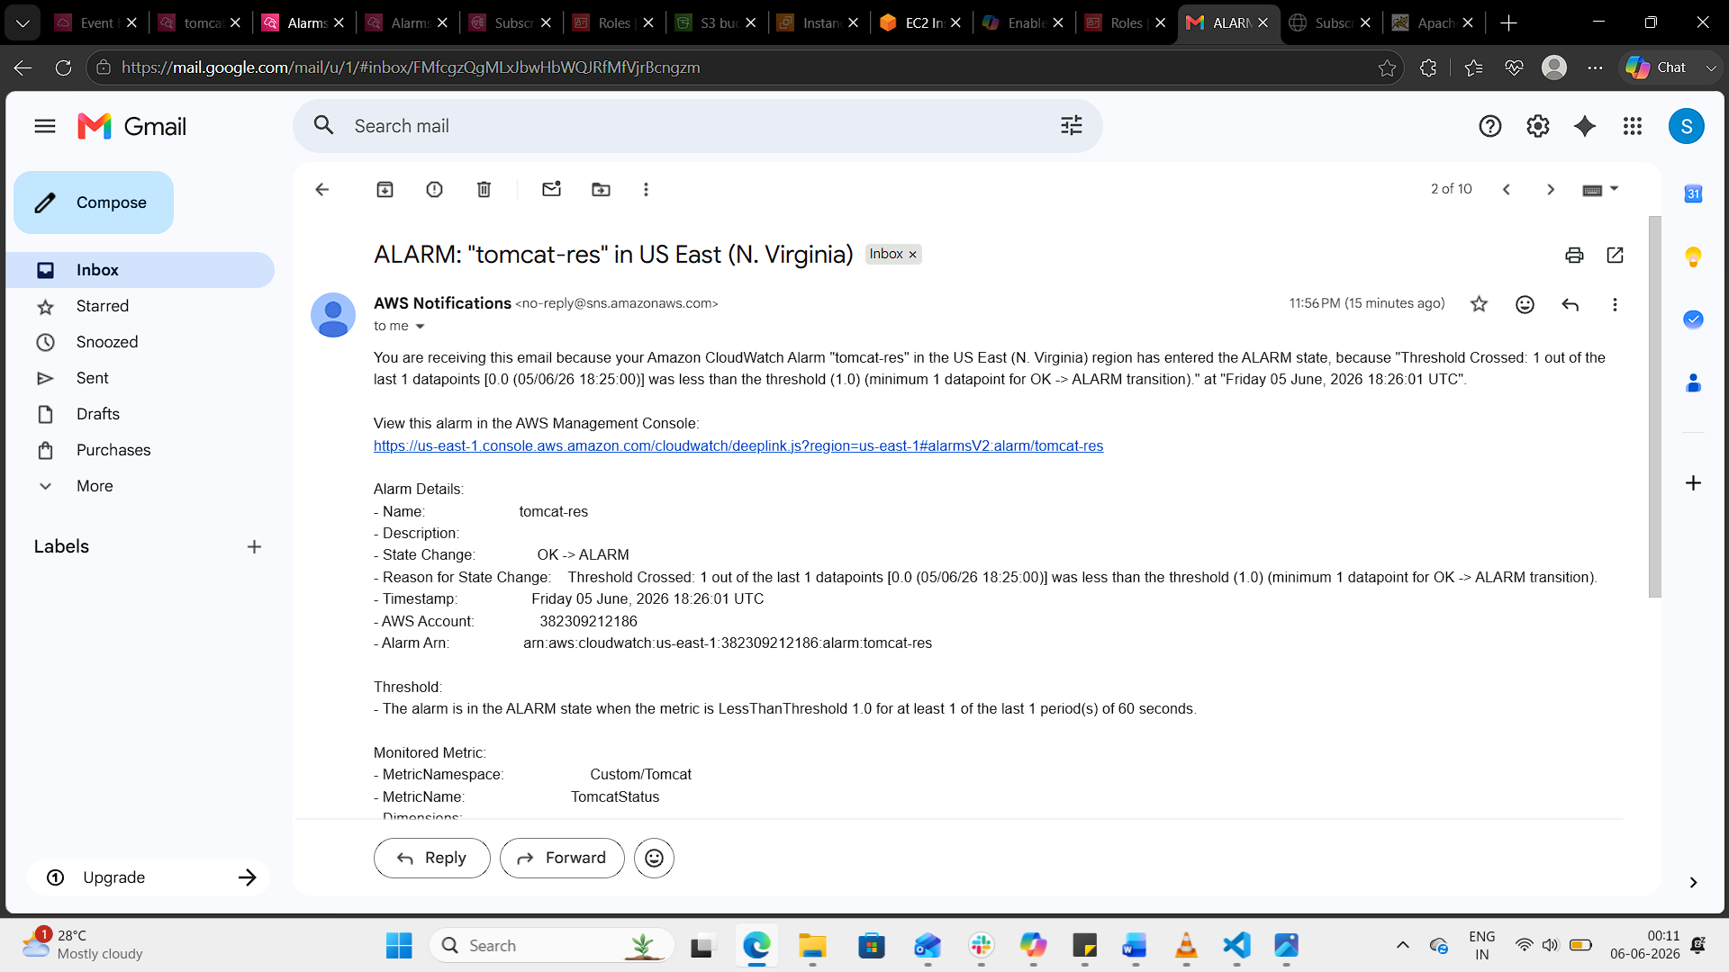

6: Create a CloudWatch Dashboard and Monitor Nginx Service to Send Alerts if Nginx is Not Running
Step 1: Verify Nginx Service
Connect to the EC2 instance

Check Nginx status:
sudo systemctl status nginx
Expected Output:
Active: active (running)

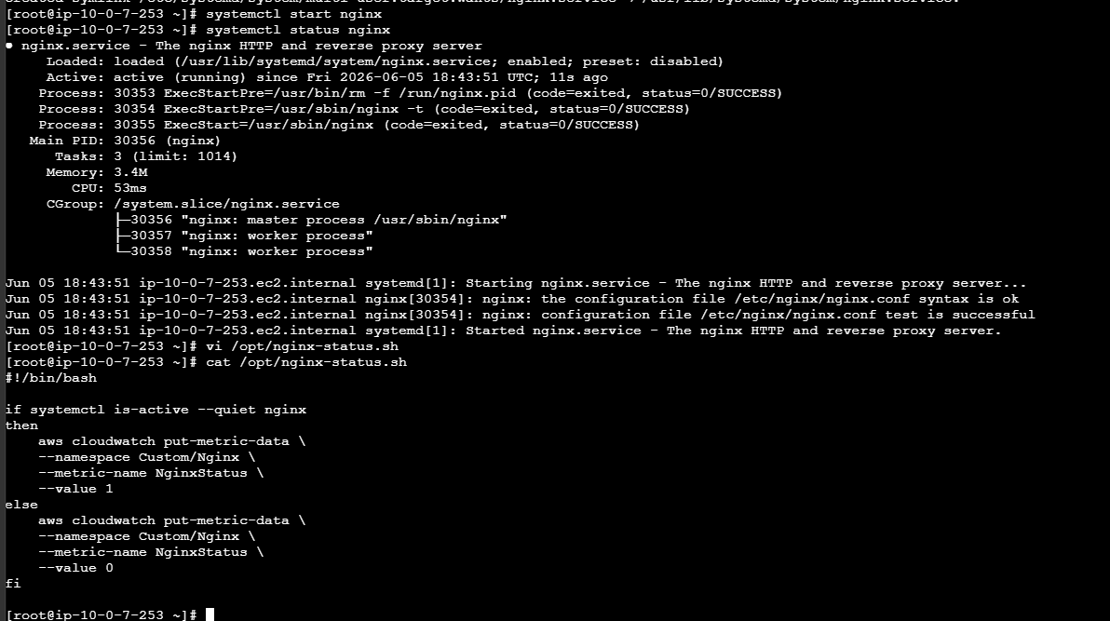

Step 2: Create Nginx Monitoring Script
Create a script:
sudo vi /opt/nginx-status.sh
Add the following content:
#!/bin/bash

if systemctl is-active --quiet nginx
then
aws cloudwatch put-metric-data \
--namespace Custom/Nginx \
--metric-name NginxStatus \
--value 1
else
aws cloudwatch put-metric-data \
--namespace Custom/Nginx \
--metric-name NginxStatus \
--value 0
fi
Save and exit.
Provide execute permission:
sudo chmod +x /opt/nginx-status.sh

Step 3: Configure Cron Job
Edit crontab:
crontab -e
Add:
*/1 * * * * /opt/nginx-status.sh
Purpose:
- Metric Value = 1 → Nginx Running
- Metric Value = 0 → Nginx Stopped

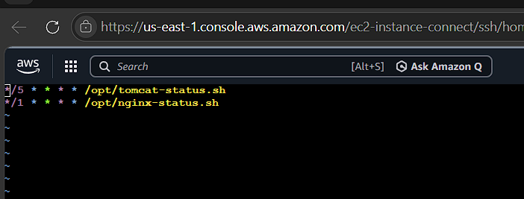
Step 4: Verify Custom Metric
Wait 2–3 minutes after cron executes.
Navigate to:
CloudWatch → Metrics → All Metrics → Custom Namespaces
Verify namespace:
Custom/Nginx
Verify metric:
NginxStatus
Expected Values:
Value | Meaning
1 | Running
0 | Stopped

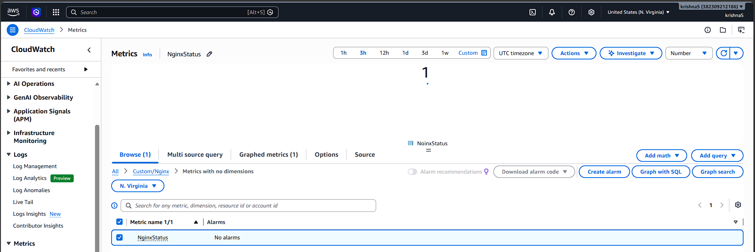
5: Create CloudWatch Dashboard
- Open CloudWatch.
- Select Dashboards.
- Click Create Dashboard.
Dashboard Name:
Nginx-Monitoring-Dashboard
- Add a Line Widget.
- Select:
Custom/Nginx
- Choose:
NginxStatus
- Save Dashboard.

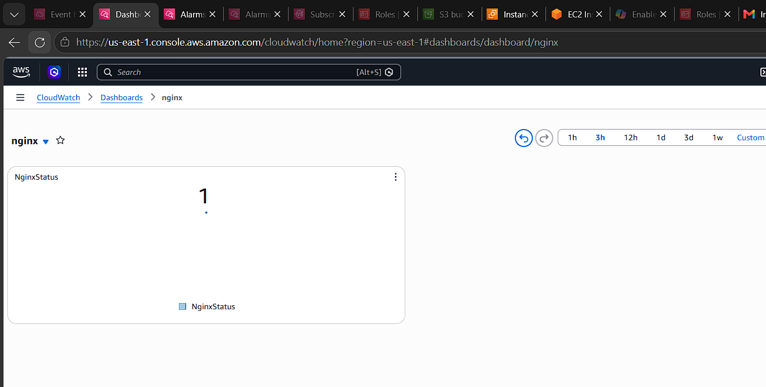
Step 6: Create CloudWatch Alarm
Navigate to:
CloudWatch → Alarms → Create Alarm
Select Metric:
Custom/Nginx
→ NginxStatus
Configure:
Parameter | Value
Statistic | Average
Period | 1 Minute
Threshold Type | Static
Condition | Less Than
Threshold Value | 1
Meaning:
Alarm triggers whenever Nginx status becomes 0.
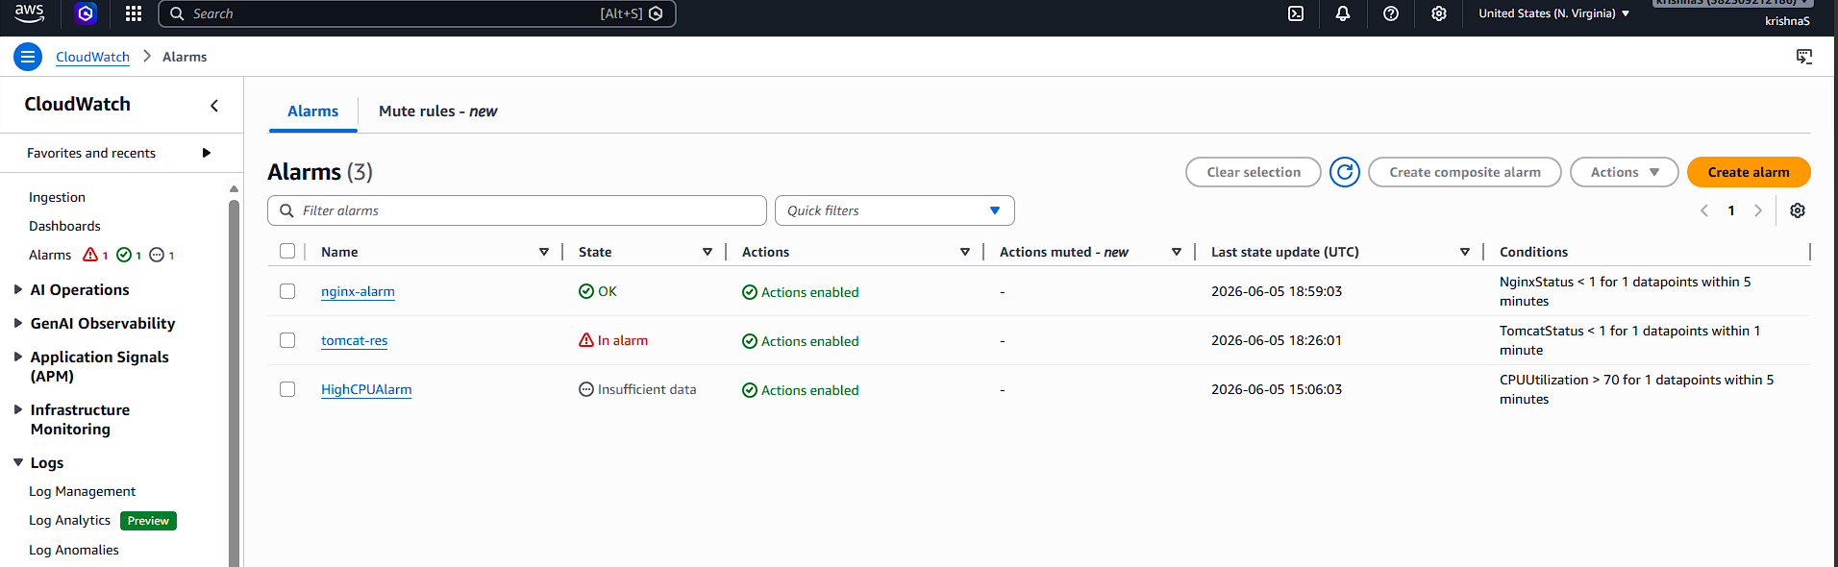
Step 7: Configure SNS Notification
Select:
Send notification to an existing SNS topic
Choose SNS Topic:
CloudTrail-Alerts
Alarm Name:
Nginx-Service-Down
Create Alarm.

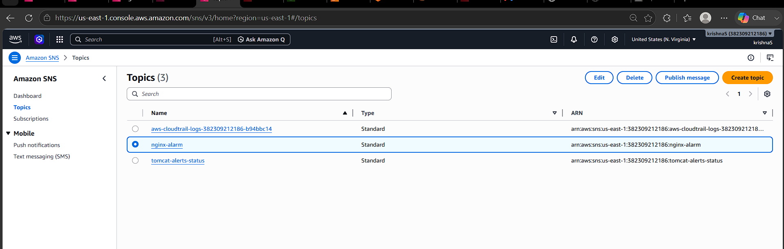
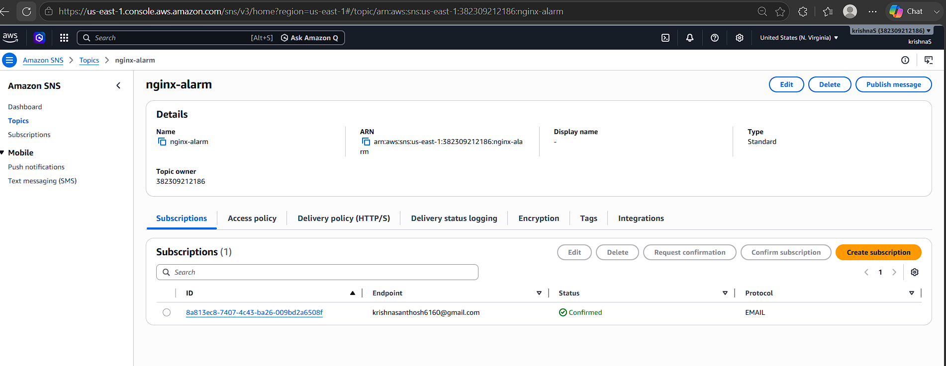

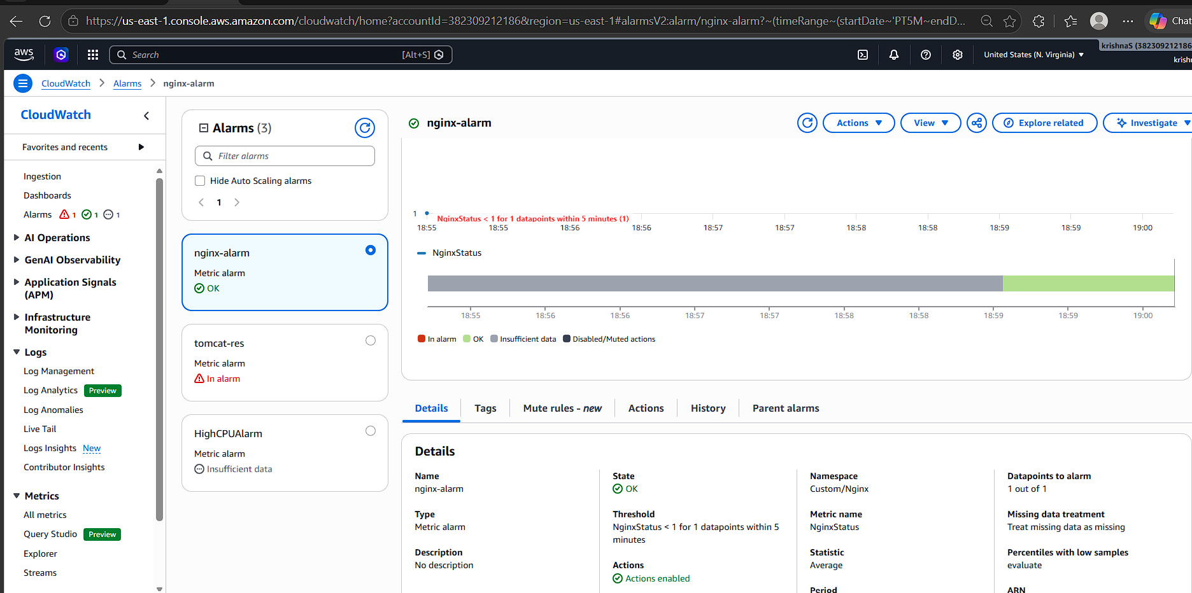
Step 8: Test Monitoring
Stop Nginx:
sudo systemctl stop nginx
Verify:
sudo systemctl status nginx
Expected Output:
inactive (dead)
Wait 1–2 minutes.
Observe:
- NginxStatus changes from 1 to 0.
- Alarm state changes from OK to ALARM.
- Email notification is received.
